SMA
USER GUIDE
Version 2.3

1 Revision History 5
2 Introduction - SMA–Service Management Administration 5
3 How to SECTION 5
3.1 Obtain User ID 5
3.2 Service Tag Management 6
3.2.1 Display a Service Tag 6
3.2.2 Set Service Tag Status 6
3.3 Correlation Management 6
3.3.1 Service Correlation 7
3.4 Operational Date-In-Service 7
3.4.1 Find Date of Service When It Turns Operational 8
3.5 PVC Management 8
3.5.1 Perform PVC Correlation 8
4 Change Control Procedures – User Group 9
4.1 Role of the User Group 9
4.2 Change Process 10
5 Standard Features In SMA 10
5.1 FEATURES 11
5.2 Standard User Buttons 12
6 Customer Tab 12
6.1 Search Customer Name 12
6.2 Search Customer Detail 13
6.3 Create, Change, or Delete Customer Detail 14
6.4 Create, Change, or Delete Customer Name Alias Detail 15
7 CUSTOMER ADDRESS 15
7.1 Search Customer Address 15
7.2 Create, Change, or Delete Customer Address Detail 16
8 Service Location 17
8.1 Search Service Location 17
8.2 Create, Change, or Delete Service Location Detail 18
8.3 Create, Change, or Delete Service Location Contact Detail 19
9 Contact Information 20
9.1 Search Contact Information 20
9.2 Create, Change or Delete Contact Detail 21
10 Contact Roles 23
10.1 Search Contact Role 23
10.2 How Remedy Uses Contact Information 23
10.3 Create, Change or Delete Contact Role Detail 25
11 Customer Service 25
11.1 Search Customer Service 26
11.2 Create, Change, or Delete Customer Service Detail 26
11.3 Create, Change, or Delete Customer Service Contact Detail 29
11.4 Change Customer Service Type (Upgrade/Downgrade Service) 30
11.5 Move Location of Customer Service 30
11.6 Customer Contact – E-mail Setup 31
12 Facility Tab 31
12.1 Facility Search 31
12.2 Facility Detail General Information 32
12.3 Facility Details Specific to Service 36
13 Asset Tab 38
13.1 Asset Search 38
13.2 Asset Detail Identification 39
13.3 Asset Catalogue Search - Make, Model and Part Search 41
13.4 Asset Classification Search – Asset Class, Asset Subclass, Asset Type 41
13.5 Create, Change, or Delete Asset Catalogue, Make, Model, Part Number and Asset Class, Subclass or Type 42
14 Managed Objects Tab 42
14.1 Search Managed Objects 42
14.2 Create Managed Object 43
14.3 Inactivate Managed Objects 44
15 PVC Tab 44
15.1 Search PVC 45
15.2 Create, Change, or Delete PVC Detail General Information 46
16 Correlation Tab 49
16.1 Search Correlated Elements 49
16.2 Managed Correlation Detail Information 49
16.3 Activate/Terminate Customer Service 50
17 Order History 51
17.1 Search Order History 51
17.2 Display Order History Detail 52
18 Administration Tab 52

Revision History

Date | Version | Contributor | Comments
1998-06-22 | 1.0 |  | Initial Document
2000-02-28 | 2.0 | Bruce Adlington | Revised to reflect system version 4.6.1  (This document is still under construction)
2000-03-27 | 2.1 | Bruce Adlington | Updated section 6 – Managed Objects
2000-10-05 | 2.2 | Ann Pyear | Revised to reflect system version SMA2, Version 1
2000-11-26 | 2.2a | Ann Pyear | Add Order History
2001-10-01 | 2.3 | Karen Gerstendorfer | Document reconstruction.

Introduction - SMA–Service Management Administration

SMA is a system, created by TELUS, used to make the tasks of creating and managing Network Services more efficient. It is an interface to the ESD (Enhanced Services Database). The systems process is as follows. Customer orders are:
- Created in SRT and DOCS
- Tracked through ECOPS
- Designed on Visio
- Trouble reporting is via Remedy and T2
- Billed on Arbor

SMA is a critical link in TELUS’s ability to provide service management because it integrates all the activities and data needed to manage our contracts with our customers. Detailed processes for the Enhanced Services can be found at http://esots.tsl.telus.com.

How to SECTION

Obtain User ID

The following information is required for each SMA user in each functional group:
- User Name
- User Location (including building and floor)
- M# of User's desktop or laptop
- User ID
- Functional Group (used to create security profile)
- E-mail ID, only if your ID does not follow the standard format of firstname.lastname@telus.com
- TAC Domain

The above information is used to establish the user's security profile. Security profiles must be established to provide the user with access to SMA2 and to establish the authority to execute specific SMA2 transactions.

The SMA2 system is located at http://tacabweb10/sma2 . A minimum version of Internet Explorer 5 is required to effectively use the system.

Service Tag Management

Service tags are used to indicate what services are components of the overall solution provided to a customer’s specific location. When a trouble ticket is created, all service tags are active. Once the trouble has been resolved, the services not affected by the trouble need to be deactivated. The deactivation is only relevant to the individual ticket. Proper deactivation is critican when closing tickets.

Note: When a ticket is opened based on the customer name, all services that customer has are related to that ticket. The implication is if the ticket was a report of only one service being down, Remedy would track the trouble as if ALL services were down. TELUS would be rebating money to the customer for services operating normally.

Display a Service Tag

- Select Start button then Programs then Remedy AR System then AR User.
- Type in User Name and Password.
- Select File then Open Query, then Modify from the tool bar.
- Select Query then List from the tool bar.

The service tag list shown above was generated on a trouble ticket in which the customer reported an e-mail routing problem on their RAS (Remote Access Service). The ticket indicated a SLA of 7x24, therefore the maximum outage is 130 minutes. If the trouble ticket was closed as a service affecting outage over 130 minutes, all services showing active in the service tags list would be rebated. Obviously, we want to only rebate on services not available.

Set Service Tag Status

Now that the service tags are listed.

- Click on a single tag. To select several, use CTRL and click or SHIFT and click to select a range.
- Select Query then Modify All.
- Click the appropriate Active or Inactive button.
- Close window.
- To refresh the list select Control Home and verify changes.

Correlation Management

Correlation management is critical for troubles and changes.

For troubles, correlation management is important because several customers often use the same network devices. If a device traps or misses three polls, Spectrum will notify Remedy T2 (via TEF) to cut a trouble ticket. If a device is properly correlated to all customer services that use it, T2 will automatically list all customer services impacted by the failure on the trouble ticket.

For changes, correlation management allows Operations to easily generate an e-mail to notify all customers affected by a change. This is especially useful since customers must be given five working days notice that their service will be unavailable.

Note: At this time INOSS can not cut trouble tickets for individual ports on a catalyst but will flag the entire catalyst as down. Operations must then determine specifically which ports and customers are affected.

Service Correlation

Steps:

- Select the Correlation tab at the main menu.
- (Outside SMA, open the design specification on the group drive. Determine which services need correlation from the visio diagram.)
- On the ‘Correlation’ screen, search for each service on the visio diagram (found in step above) by typing in the search criteria and selecting the Search button. Each service name is a unique identifier defined by the Implementation Managers in AB or the Engineering Clerks in BC.
- When the desired service to be correlated is found in the search results, select it by double-clicking on it.
- The ‘Managed Correlation – Details’ screen will open.
- Ensure the Create Service Tag and Check Service Dep check boxes are selected.
- Select the +MO button to correlate a managed object to the customer service.
- The ‘Managed Objects Search’ screen will open. The managed object will autopopulate the Correlated Elements field once clicked on from the ‘Managed Objects Search’ screen search results. The ‘Managed Objects Search’ screen can bring a list of all managed objects in the ESD database and classified as operational. Managed objects are individual network elements/devices such as switches, routers, catalysts, etc.
- To correlate facilities to this customer service, select the +Facility button.
- The ‘Facility Search’ screen will open.
- Type in search criteria to search for the appropriate facility, select Search button.
- Select the appropriate facility displayed in the search results by double-clicking on it to correlate the customer service.
- Repeat steps 7-12 for correlating root services to the customer service.
- Once all service correlation is complete, set the Service Status from Design Phase to Operational.

Note: Ensure that service correlation is performed correctly. Incorrect service correlation will have major downstream effects with Service Management and Billing.

Root services are a list of services that contain network elements that can be used by a variety of other services. Root services may be composed of managed objects and circuits and in many cases uses even other root services.

Root services are useful because they serve as re-usable building blocks for the network. Once the service is correlated it becomes a root service and can be reused in another service. When a root service is correlated to a customer service, the service automatically inherits the connection to the network elements attached to the root service.

Operational Date-In-Service

SMA can identify when a service has turned operational. The Date-In-Service field that resides in the ‘Managed Correlation Detail’ screen is manually entered once the service is marked as operational. Since the Date-In-Service field is entered manually, this information is not fool-proof and may not be present even though the service is operational.

Find Date of Service When It Turns Operational

Steps:

- Select the Correlation tab at the main menu.
- The ‘Correlation Search’ screen will appear.
- Enter a portion of the customer name in the Customer Name field. The search results will display all services associated with the customer.
- Select the service that needs to have the Date-In-Service checked by double-clicking on it.
- View the Date-In-Service on the ‘Managed Correlation Detail’ screen..

PVC Management

TELUS charges internetworking customers for ATM traffic between sites connected to the ATM network. PVC management is used to correlate the endpoints of PVCs (logical customer service locations) so that usage can be billed to the customer. This is done from a file in SMA.

When ATM paths are created in the Alcatel 5620 EMS (46020), 5620 is configured to collect statistics into a file. All new paths with statistics collection enabled are daily added to a table in SMA.

SMA must be worked daily to correlate or associate these paths to the correct customer to ensure that the Arbor billing system can bill for the usage.

Perform PVC Correlation

Steps:

- Select PVC tab from the main menu.
- Enter search criteria in the various fields in the ‘PVC Search’ screen including selecting the Outstanding/Uncorrelated PVCs checkbox.
- Select the Search button.
- From the search results, select the desired PVC by double-clicking the line.
- The ‘PVC Detail General Information’ screen will open.
- Fill out and verify the following ‘PVC Detail General Information’ for the PVC. The ‘PVC Detail General Information’ is used in the collection of daily usage statistics. If this information is missing or incorrect, the customer will not be billed accurately for their service.
  - Type field will read ‘ATM-PVC’ for all cases.
  - PVC Number field shows circuit number when a PVC is detected.
  - PVC Name field defaults to the circuit number.
  - PVC Start Date field shows the date the system starts to collect usage statistics.
  - PVC Provider field shows the organization that provisions the circuit.
  - Operational Status field, default is ‘Unknown’.
  - Usage Calc Type field. There are three possible selections:
    - FREE – When the PVC is not to be billed to the customer.
    - INET – When the PVC connects an internetworking service where both sides of the service are being billed for receipt usage.
    - LAN-IC – When the service is a LAN interconnect and only one side of the service is being billed to a customer and the other side connects to a TAC-CO or POP.

Operational Status Code field identifies the status of the PVC circuit. When the PVC is autodetected, this status will be set to ‘Unknown’. When Operations has completed the Billing, Side A and Side B information, they change this status to OPER (Operational) indicating the PVC is fully connected and collecting usage for a customer service.

Enter or verify the ‘Side A’ (Customer Side) and ‘Side B’ (TAC Side) information as follows. Side A and Side B information identifies the logical connection of the PVC circuit and is also critical for accurate billing and reporting. If this information is missing or incorrect, the customer will not be billed accurately for their service.

- Side A Section of ‘PVC Detail General Information’ Screen:
  - Customer Service A field. Select the name of the service for endpoint A from the drop down list of defined services.
  - If the list is too long, try copying the managed object name and pasting it into the Managed Object Name field.
  - Select Enter. The results will provide the Customer Service Name and Service Location.
  - Cross-reference the VISIO drawing to ensure the Customer Service Name is correct.
  - Customer Billed for Side A field. This field will default to the customer who is using Customer Service A. If a different customer should be billed for this service, change it here.
  - Service Location A field. This field will default to the service location for Customer Service A.
- Side B Secton of ‘PVC Detail General Information’ Screen:
  - Customer Service B field. Select the name of the service for endpoint B from the drop down list of defined services.
  - Copy and paste the managed object name for the B side of the circuit.
  - Select the Enter button.
  - Select the Customer Service Name for the second site.
  - Customer Billed for Side B field. This field will default to the customer who is using Customer Service B. You can change this value if a different customer should be billed for the service.
  - Service Location B field. This field will default to the service location for Customer Service B.
- Select the Save button at the bottom of the screen.
- Enter Alias Circuit Number (only if applicable). If a company other than TAC provides the circuit, use this field to enter information that can be used to refer to the circuit in the other company.
- Change the Operational Status field to ‘OPER’.
- Close the ‘PVC Management’ screen.

Note: The information entered in the Side A and Side B sections define Endpoint A and Endpoint B for the circuit for billing purposes. It is important to ensure the information you enter for side A and B accurately reflects how the PVC was defined in Newbridge 46020 and the billing situation reflected by the Usage Calc Type.

Change Control Procedures – User Group

Role of the User Group

The User Group is made up of Super Users identified in the SMA Process Ownership Model plus additional representatives from the IT department who represent systems that may be affected by the proposed changes.

The role of the Super User is to represent their peer group in the ownership of process, function, and data for their area of responsibility. Super User responsibilities include:

- Identify and collect ideas for improvements from peer users.
- Analyze the impact of the improvement with regards to their function(s).
- Responsibly escalate improvement ideas and issues that overlap functional boundaries with the User Group for discussion.
- Participate in issue resolution to ensure the needs of the entire Service Management process are met.
- Update the user procedures document to reflect changes.
- Disseminate new and changed information to their peer group.

The role of the user group meeting is to serve as a forum where all issues regarding any process, data or system function can be shared with other Super Users and IT representatives. The purpose is to fully understand the implications that a change or addition may have on other groups in the process. The primary responsibility of the user group meeting is to:

- Review and prioritize improvement ideas raised by Super Users since the previous meeting.
- Resolve issues affecting more than one functional area.
- Ensure system change requests are logged in the C3S program
- Review and approve change requests implemented in the latest release.

Change Process

Each Super User is responsible for issue resolution and maintenance of documentation within their functional areas. Any changes relating to data, process, or system should use the following process.

- Conduct a preliminary analysis of the change request ensuring the change request is valid and it cannot be solved with training. If the change request is valid, identify the groups that may be affected by the change. Get input from the identified Super Users regarding the potential impact of the change request.
- Log the change request as an item on the user group meeting agenda. This includes e-mailing a note to the User Group Coordinator (currently Lee Ettinger). The note should contain a short description of the issue and an estimate of the amount of time it will take to fully discuss the issue in the meeting. Be realistic in your time estimate so that the meeting can be planned to cover all items.

AT THE USER GROUP MEETING

- Review and discuss items on the agenda. The Super User responsible for logging the item should give background information on the change request for the rest of the user group.
- If it is determined by the user group that the change request is required and valuable continue with step 5, otherwise the issue should be closed and the Super User responsible for logging the item should communicate the resolution to the original requestor.
- If the change request results in enhancements or changes to the system, log the change request in the C3S application.
- If the change request results in process or data changes, each Super User is responsible to update the new process in the procedures document and also to communicate the new procedures to their peer user group.

Standard Features In SMA

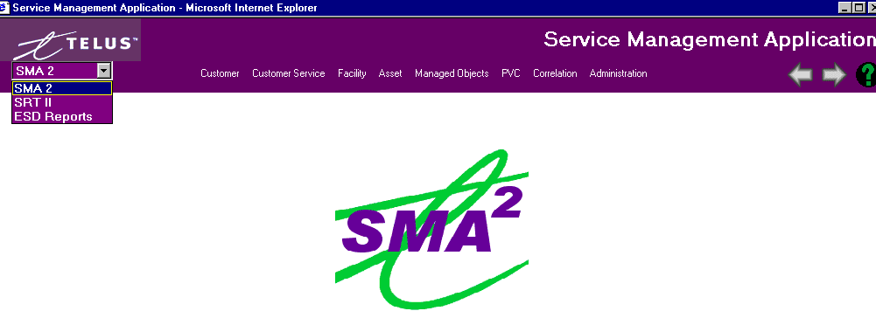
Pulldown menu for INOSS applications
User Action buttons

Forward/Backward (navigate screens)

? - SMA User Guide
SMA2
Main menu
choices

FEATURES

Alias Name Field Identifiers – If there have been company takeovers, mergers, etc. these alias names will assist in searching process. Used for Customer Name, Facility Number, and Managed Object Name. If you know the old name for a company i.e. “H.A. Simons” and put this criteria in the ‘Customer Name’ field, the search results will display the new customer name of “AMEC”.

Arrow Keys – The arrow key icons when located at the top right hand side of the screen underneath the SMA logo enables the user to navigate screens backward and forward.

Drop Down Menus – On any drop down menu, there is always a blank selection available.

Drop Down Menu (Under TELUS Logo – top left side of screen) – This drop down menu, allows you to go quickly to other INOSS appliations (SRT2 and ESD Reports).

Main Menu/Tab Options/Navigational Bar – The main menu/tab options/navigational bar is located in the purple header from left to right across the top of the screen. These main menus are available from any screen in SMA.

Mandatory Fields - Any field requiring criteria to be entered into it is marked with with an asterisk beside the field name.

Question Mark - The question mark located at the top right hand side of the screen underneath the SMA logo enables the user to access the SMA User Guide.

Quickly GoTo Drop Down Menu - This drop down menu located at the top right side of the screen allows for easy navigation between screens in SMA.

Search Capabilities (Wild Card) - There are enhanced search capabilities with a wild card search using the ‘%’ character for unknown characters at the beginning or ending of search criteria. If you wish to search for all customer names that contain ‘and’ in the name, you would enter ‘%and’ as search criteria in the ‘Customer Name’ field. SMA automatically assumes a wild card at the end of your search. Text searches are not case sensitive.

Search Results/Excel Icon - Any search results can be captured and saved into an excel format by selecting the ‘Excel Icon’ located next to the number of search records. The excel spreadsheet can be saved in your own directory and the data can be manipulated in utilizing the excel program.

Standard User Buttons

… Button (Look-Up) – This button is located to the right of an empty white field. When selected, this button accesses the ESD database and the user searches and selects a detail record from the ESD database. If this information is not in the ESD database, the user is required to populate the fields in a new detail record which will appear. The user cannot populate these fields by typing information directly into these fields.

Active Only Checkbox – When selected, this checkbox only displays all records with the ‘active only’ flag on it. When a record is deleted, the ‘active only’ flag is deselected in the database.

Clear – When selected, this button removes any inputted criteria in the fields and returns it to its default state. In many cases, this would be with no criteria in any fields.

Clone – When selected, this button clones the existing record that is currently displayed. It is not available on all screens.

Delete – When selected, this button removes or ‘soft’ deletes the selected record. Use ‘terminated’ status for discontinued circuits.

New – When selected, creates a new record.

References – details associated records. Important when deleting records.

Save – saves the record.

Search – When selected, initiates a search in SMA or the ESD database based on the inputted criteria.

Customer Tab

Customer, address, and contact information are captured in SRT/DOCS. It should not be necessary to add customer data using SMA. SMA is used to maintain data. By selecting the Customer field, an additional navigational menu appears. The options on the additional navigational menu are:
- Search
- Address
- Service Location
- Contact
- Contact Role

Search Customer Name

From the SMA Main Menu select Customer then Search. The user can search for the customer by entering criteria using any of the fields shown below and then selecting the Search button. A legal name, short name, or alias can be used in the ‘Customer Name’ field when searching. A list of customers will appear from the search query in the bottom portion of the screen. If the search query is lengthy, the user can select the ESC button on the PC to interrupt the task.

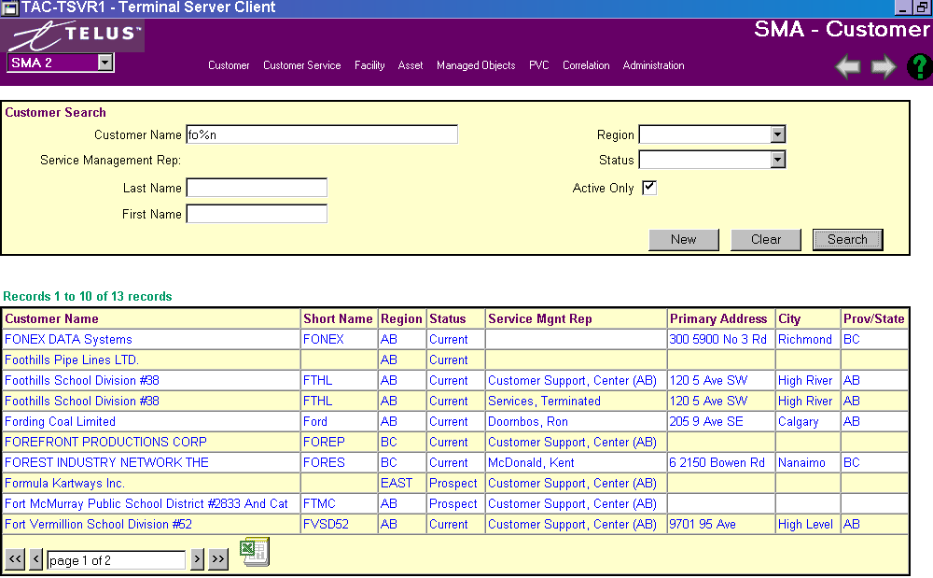

Double click on the desired selection to go to Customer Detail.

Search Customer Detail

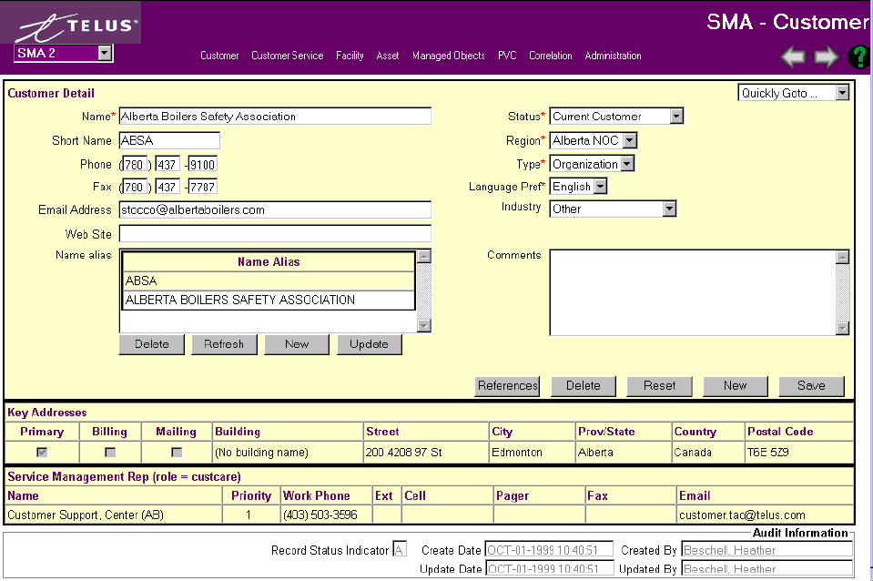

This screen is available when the desired customer is searched and selected from the ‘Customer’ tab. Field descriptions are on the next page. Key Address and Service Management Rep information can be found on extractions from ‘Address’ and ‘Customer Contact’ screens.

Create, Change, or Delete Customer Detail

If the customer does not exist, it must be added to the ESD database. This should only be necessary if there is no DOCS order issued.

Select New on Customer Search screen to bring up Customer Detail screen.

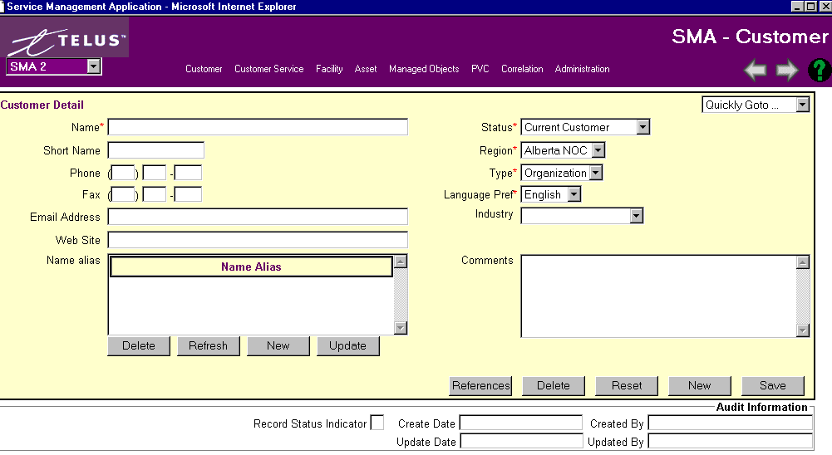

Fields:

Name - should contain the legal name of the company. Great care should be taken to ensure the precise company name is entered. The client name is used on reports and correspondence to the client and therefore is important it is as accurate as possible.

Short Name - is used as a short reference to the legal client name. For example, Client Name: TELUS Advanced Communications, Client Short Name: TAC. Once the short name is defined, it is used as a component of the service name, and used to access HealthNet and CURE reports. The short name is a maximum of 5 characters.

Phone#, Fax#, E-Mail Address, Web Site - fields are contact information for this customer.

Name Alias - will always show the Customer Name and Short Name. If there are additional names, i.e. business takeovers, nicknames, etc. adding these will help in the searching capabilities.

Status - select from drop-down menu, i.e. Current Customer, Perspective Customer.

Region - select from drop-down menu, i.e. Alberta NOC, BC NOC, Eastern NOC.

Type - select from drop-down menu, i.e. Organization, Person.

Language Pref - choose from drop-down menu, i.e. English, French.

Industry - select from drop-down menu, i.e. Education, Finance, etc.

Comments - any additional information pertinent to the customer.

You can use the Quickly GoTo to access the Address, Asset, Contact, Contact Role, Correlation, Customer Service, Facility, Managed Object, PVC or Service Location screens.

Create, Change, or Delete Customer Name Alias Detail

This screen is used when the New, Update, or Delete buttons under the ‘Name Alias’ section of the ‘Customer Detail Screen’ is selected. Entering the ‘Alias Name’ in the ‘Customer Name Alias Detail’ screen will link the alias name to the ‘Customer Detail’ record. This is used when company mergers, name changes, or takeovers take place. A new ‘Customer Detail’ record then doesn’t need to be created and the history of the customer account is preserved.

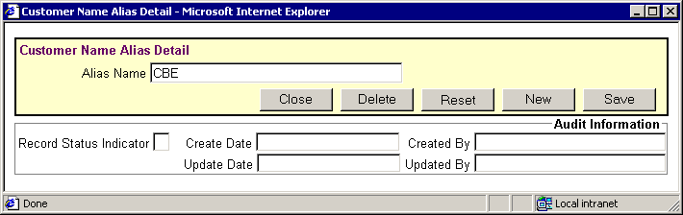

FIELDS:

Alias Name – The old customer name, the merged company name, or associated company name is entered in this field.

CUSTOMER ADDRESS

Search Customer Address

From the SMA Main Menu select Customer then Address.

Since a large number of addresses in SMA start with a floor or suite number, use a wild card ‘%’ at the beginning of your search. In the search results, if none of the address types are checked assume the address is a service location.

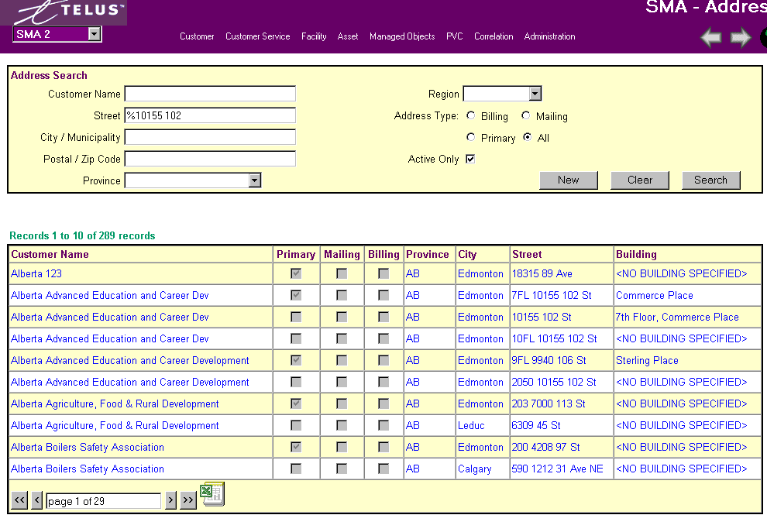

Create, Change, or Delete Customer Address Detail

To create an address, select New on ‘Search’ or ‘Address Detail’ screen. This is only necessary if there is no DOCS order issued. There must be an address for every service location.

Note: An address should be changed only if the information has been entered incorrectly. If the customer is moving to a different address, a new address record should be created.

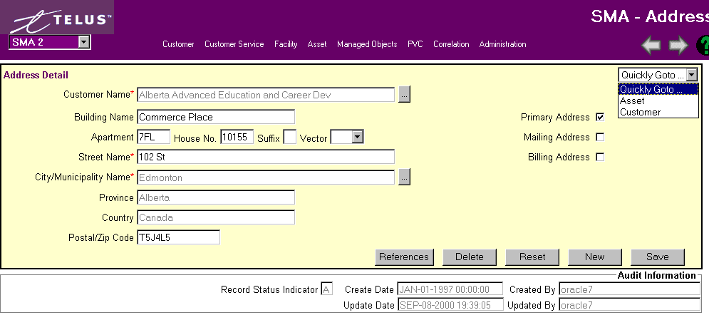

Fields:

Customer Name – Use the Look-Up button to take you to the Customer Name Search screen.

Building Name – Not mandatory. If known, it should be the official name of the building.

Apartment – Floors and suite numbers are inputted in this field.

House No. - Specific number of house or building.

Suffix – If address includes a suffix, i.e. A, 1/2

Vector – For a direction (E, N, etc) that preceeds the Street or Avenue, i.e. 3700 N. Fraser Way.

Street Name – Numeric or alpha name for a street.

City/Municipality – Use the Look-Up button to take you to the Municipality Search screen.

Province/Country – By selecting the appropriate city on the Municipal Search screen, the province and country fields are automatically populated.

Postal/Zip Code – The postal or zip code for the address is entered in this field.

Types of Address - Use the check boxes to define the address (more than one box can be checked). It is mandatory to define a Primary Business address.
- Primary Address – main address for customer.
- Mailing Address – where any information concerning the service is mailed to. May be different from the primary address. A mailing address may be different from a service address although they are located at the same premise.
- Billing Address – the address the invoice/bill is sent to. May be different from the primary address.

From this screen you can Quickly Goto either the ‘Asset’ or ‘Customer’ screens.

Service Location

Search Service Location

From the SMA Main Menu select Customer then Service Location. A service location can be searched using any of the criteria shown in the screen fields below. A list of service locations will appear from the search query. If the search query is lengthy, the user can select the ESC button on the PC to interrupt the task.

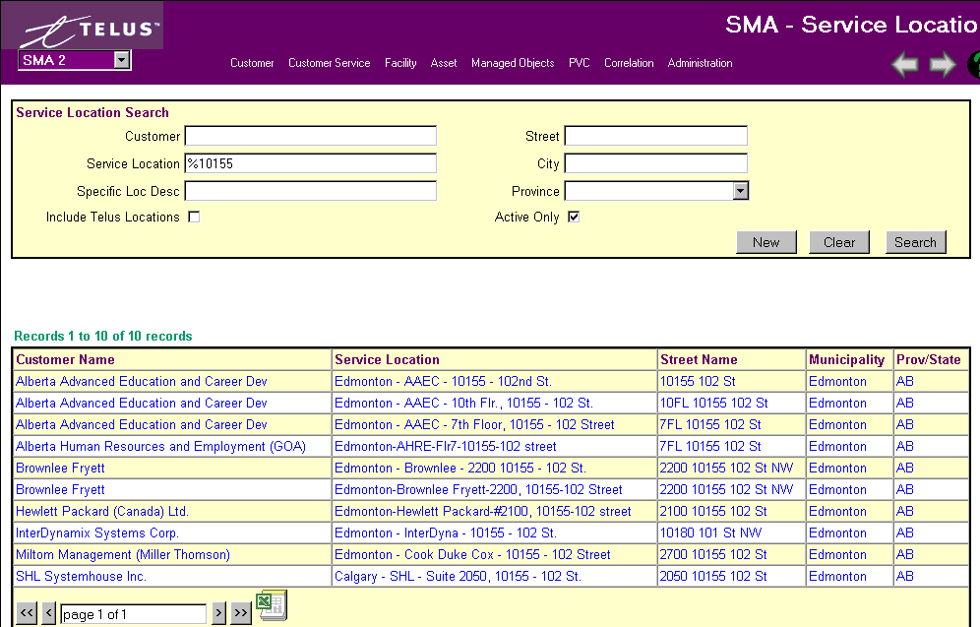

Create, Change, or Delete Service Location Detail

To create a service location, select New on ‘Search’ screen or ‘Service Location Detail’ screen. This is only necessary if there is no DOCS order issued.

Service Location Name, Specific Location Desc, Access Information, Schedule Info, and Comments can be edited by entering information directly into those fields and selecting the Save button.

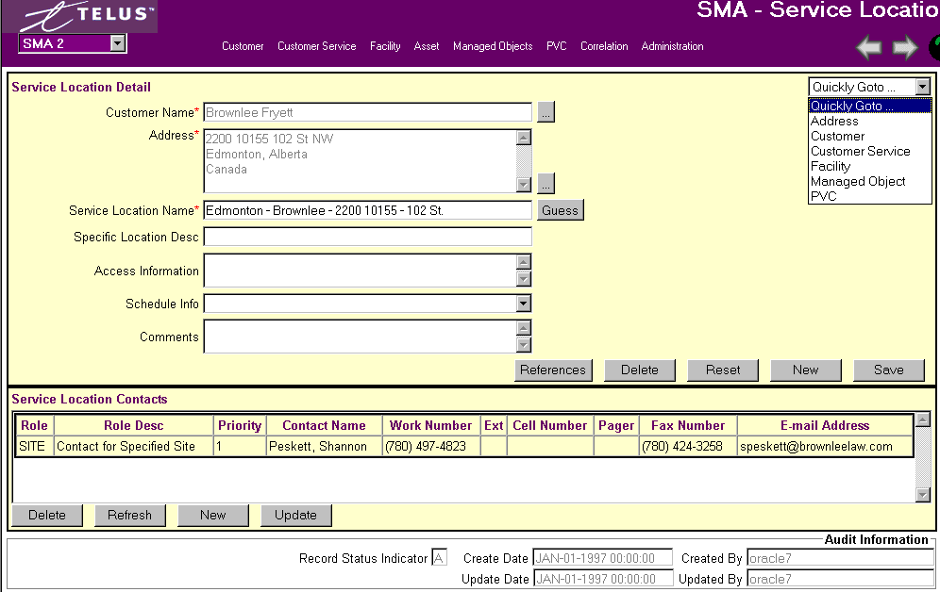

Fields:

Customer Name – Must use the Look-Up button which takes you to the Customer Name Search screen.

Address – Must use the Look-Up button, which takes you to the Address Search screen.

Service Location Name – Format is (City Name – Customer Name – Address)

Specific Location Desc. – Any additional details concerning the specific location.

Access Information – Any specific details regarding access to the building.

Schedule Info – Drop-down menu to select times when location available.

Comments – Any additional information concerning the service location.

Service Location Contacts – Options to create ‘New’, ‘Update’, or ‘Delete’.

From this screen you can Quickly Goto either the Address, Customer, Customer Service, Facility, Managed Object or PVC screens.

Create, Change, or Delete Service Location Contact Detail

The Service Location Contact Detail screen is accessed by selecting the desired Service Location Contact located on the Service Location Detail screen.

New Service Location Contact Detail information can be created by selecting the New button located at the bottom right of the screen.

To edit an existing Service Location Contact Detail, select the desired Service Location Contact located on the Service Location Detail screen. The Service Location Contact Detail screen is made available. Enter the information directly into the specified fields and select the Save button.

To delete an existing Service Location Contact Detail record, verify the appropriate Service Location Contact Detail record is selected and select the Delete button.

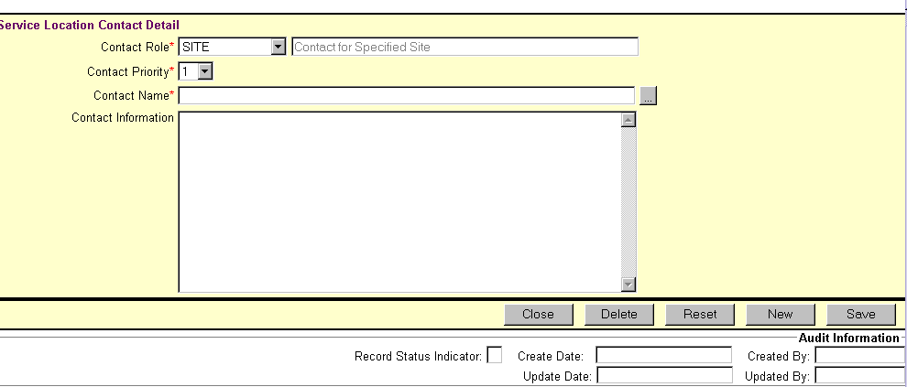

Fields:

Contact Role – Drop-down menu to select what type of role this contact has for this Service Location. When selected, a full description of the contract role appears in the adjacent field.

Contact Priority – A rating of 1 – 10 of what priority this contact has been given.

Contact Name – Must use Look-Up button to select from Contact Screen.

Contact Information – Is automatically populated based on information extracted from Contact Screen.

Contact Information

Search Contact Information

From the SMA Main Menu select Customer then Contact. Contact information can be searched using any of the fields in the header portion of the ‘Contact Search’ screen.

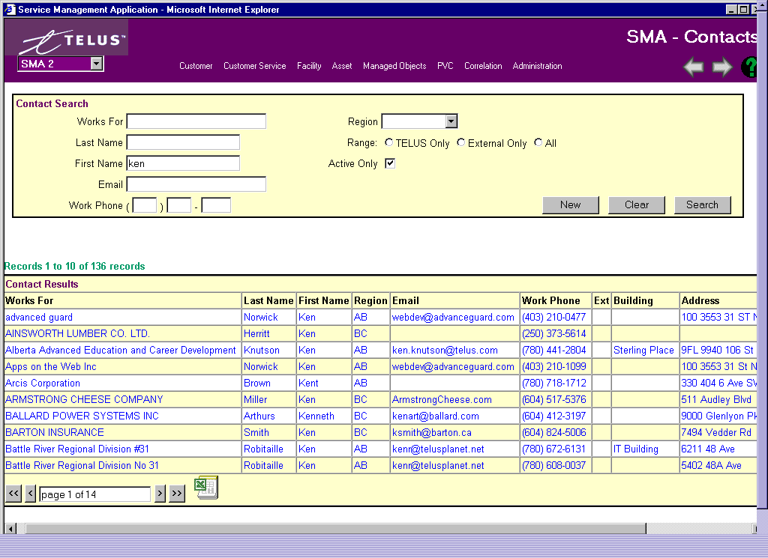

Create, Change or Delete Contact Detail

Customer Service has the overall responsibility for inserting/updating/deleting customer contact information. Implementation Managers can also make changes to this tab in order to maintain accurate customer contact information. Any other group that receives changes to this information via the customer will notify customer service by e-mail. To find the responsible Customer Service Manager select Customer Management: TAC Specific and Industry Information: Customer Care Specialist. If the ‘Customer Care Specialist’ information is missing, send the information to the Super User of Customer Management.

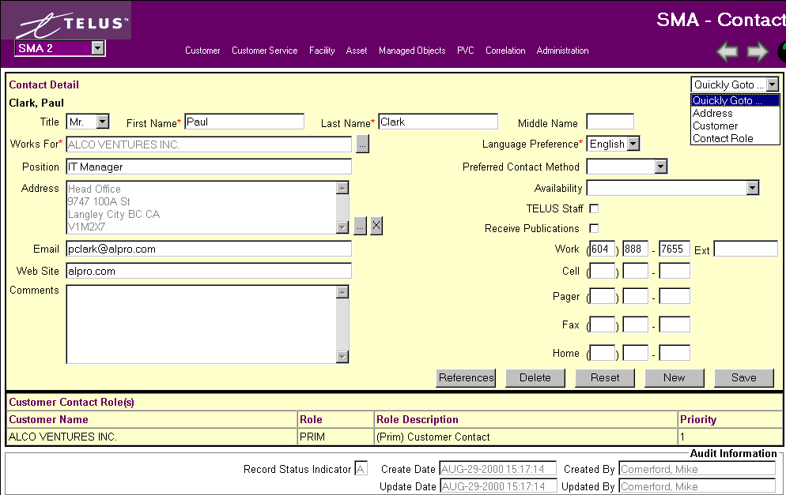

FIELDS:

Title – select from drop-down menu.

First Name/Last Name/Middle Name – customer contact name.

Works For – Use Look-Up button for customer search.

Position – Job title of the customer contact.

Address – Use Look-Up button for address search. Use the ‘X’ to remove current information.
This address is used to send communications to the contact.

E-Mail – A valid internet e-mail address for contact.

Web Site – A 50-character maximum field.

Comments – Includes notes pertaining to the customer relationship.

Language Preference – Drop-down selection on the language the contact prefers, i.e. English

Preferred Contact Method – Drop-down selection for how the contact wants to be contacted, i.e. cell, e-mail, work #, home #, etc.

Availability – Drop-down selection of the times when the contact is available.

TELUS Staff - Identifies this contact as a TELUS employee.

Receive Publications - indicates whether or not the customer wants to receive a newsletter.

Work#, Cell#, Pager, Fax# and Home # - personal information for the customer contact.

Customer Contact Role(s) – Details extracted from the Customer Contact Role Screen.

Service Location Contact Role(s) – Details extracted from the Service Location Detail Screen.

From this screen you can Quickly Goto either the Address, Customer, or the Contact Role screen.

Contact Roles

Search Contact Role

From the SMA Main Menu select Customer then Contact Role.

Use the pull-down to select and view the role definitions. Every customer must have a PRIM 1 contact. This is the primary technical contact for the customer and is the fallback contact used by the Remedy system for Trouble Ticketing. It is recommended that PRIM 1 and PRIM 2 always be assigned.

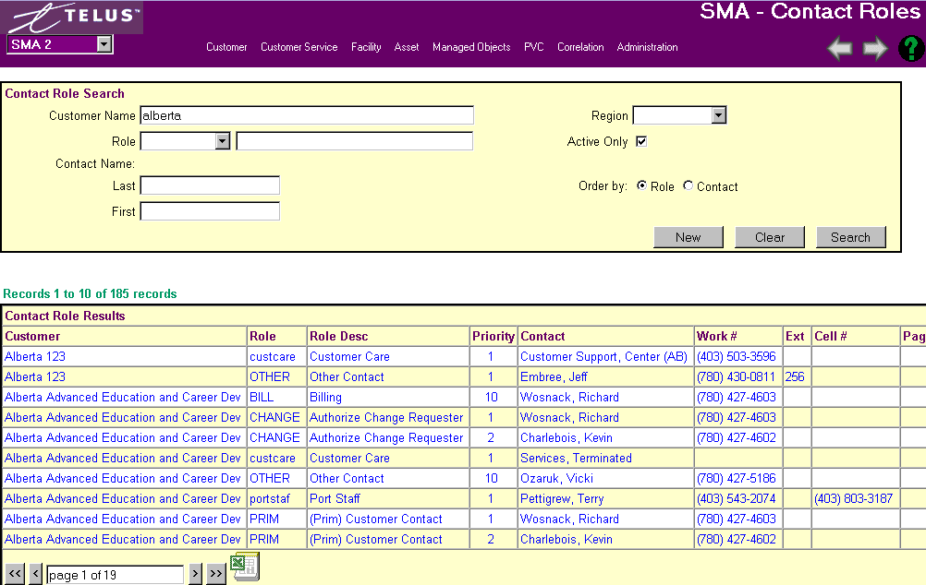

How Remedy Uses Contact Information

Phone Contact

There are often many contacts for each customer, and each contact can have one or multiple roles assigned to them. The important thing to remember is that these contacts, in the database are used by Remedy T2 and C2, and by Operations to provide contact information when alarms are detected on TAC equipment located at their sites. These automatic alarms create Remedy T2 tickets and have customer contact information attached.

By default, Remedy attaches the SITE1 contact to any automatic (Spectrum created) trouble ticket on any specific element. This only happens if a customer contact is defined as a SITE contact and the specific element is linked to that site location and customer in the SMA Managed Objects. If no site contact is available, the PRIM1 will be attached. If neither a SITE1 nor PRIM1 is defined for the customer, the contact information in the ticket will be blank. All contacts can be queried via the drop down menu on the ticket. The SERV1 contact is only used for e-mail notification.

It is valuable to have site contacts when the OSC requires confirmation of power and physical connectivity, as in most cases, the tickets are created by the systems and not called in by the customer. In cases where we have customers that want a single point of contact from a networking perspective, then SITE contacts should not be defined, and the PRIME1 should be the customer helpdesk or main technical contact (7x24).

E-Mail Contact

Contact information is also used by Operations when sending e-mail notification to customers for upcoming maintenance window activity that will affect their service as well as customer notifications and updates when a global outage occurs that affects multiple customers and services.

From both C2 and T2, an e-mail distribution can be created for the customers that are linked to the service tags on any change ticket or trouble ticket. As a result of service correlation, any element that has a change or trouble ticket can have an e-mail distribution list created for quick and easy notification. This is only possible if customer contacts are defined properly in the ESD and the correct e-mail addresses are entered.

E-mail notification (for all customer services) is sent to the following customer roles:
- PRIM1 (Helpdesk e-mail should be the helpdesk e-mail or an e-mail that distributes to multiple contacts within the organization).
- PRIM2 (Manager or Lead Communication Analyst)
- SERV1 (Technical contact for a specific service i.e. Web Hosting).

The only time a SERV1 contact needs to be defined is if a specific customer has multiple services, and for some of the services if they want a different person contacted. This is often the case when a customer has purchased both Internetworking and Internet Hosting services. The customer’s organization is such that different people can be responsible for the LAN/WAN and the Hosting Services.

Change Control

Another role is the CHANGE role. This is used by Operations to confirm a specific customer contact has the authority to request changes to an existing service. The customer change process allows a customer to request a change by e-mailing the OSC with the details. This e-mail must be received from an authorized change requestor for that customer. If a customer is going to be requesting changes, the authorized contacts must have ‘Change’ roles assigned in the ESD.

Summary

Customer contact information is defined and maintained by Customer Service Management. It is important they ensure customer contacts are correct and have the proper roles assigned to them. Service Management should verify the contact information is correct when they do their quarterly customer service reviews.

Create, Change or Delete Contact Role Detail

This screen is accessed by selecting the desired Contact Role on the ‘Search Contact Role’ screen.

To create a new contact role detail for a specified customer, select the New button located at the bottom right of the screen. Enter the information as required. Mandatory fields are marked with an asterisk. Use the Look-Up buttons next to the customer and contact fields to select the correct records from the ESD database. Select the Save button to save the information.

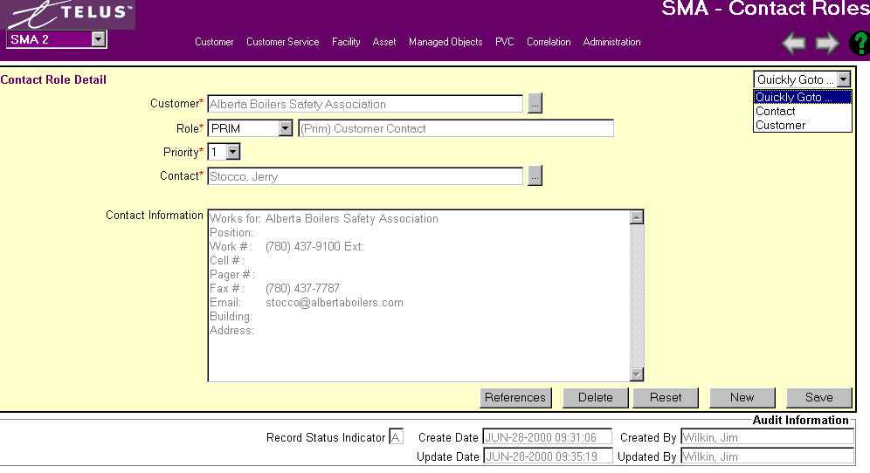

Fields:

Customer – Must use the Look-Up button, which takes you to the Customer Name Search screen.

Role – Drop-down selection for the type of role the contact has. Once the selection is made, the full role name will be displayed in the adjacent field.

Priority – Choose from 1 – 10 as what priority the contact role has.

Contact – Must use the Look-Up button, which takes you to the Contact Search screen.

Contact Information – Information is extracted from the Contact Search screen.

From this screen you can Quickly Goto either the ‘Contact’ or ‘Customer’ screens.

Customer Service

This tab enables the user to search for existing or create customer service information. By selecting the Customer Service field, an additional navigational menu appears. The options on the additional navigational menu are:
- Search
- Email Setup

Search Customer Service

From the SMA Main Menu select Customer Service then Search. Search for the customer service name using any of the fields shown below. A legal name, short name, or alias name can be used in the Customer Name field when searching. This screen also shows Customer Name, Region, and Support Group.

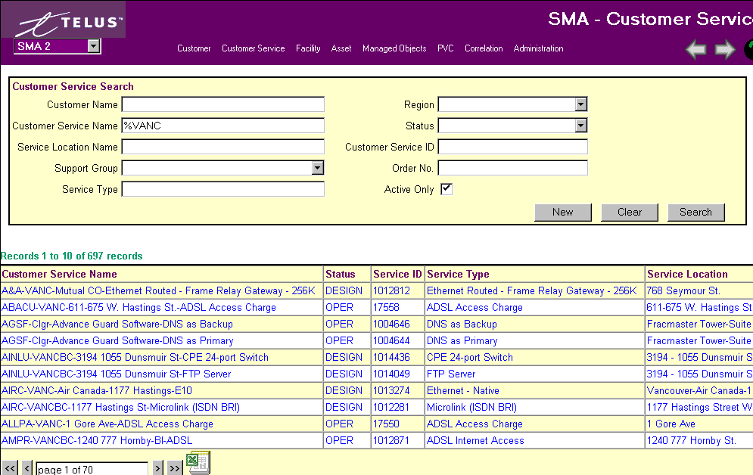

Create, Change, or Delete Customer Service Detail

The Customer Service Name is a unique reference to the customer’s service. The standard naming convention is as follows:

Customer Short Name ‘-‘ Abbreviated City Name ‘Abbreviated Province Name’-‘ Unique Identifier (i.e. building name, street address, floor number, etc.) ‘-‘Service Type’.

Example: ACB-EDTN-Cross Cancer Institute-Ethernet Native.

If the service is Ethernet Native, Fast Ethernet Native, LAN IC, or LAN Extension, a second service needs to be built for standard reporting. The service name is the same as the name given to the service, with ‘SR’ added in front of the service type.

Example: ACB-EDTNAB-Cross Cancer Institute-SR-Ethernet Native.

The DOCS system can build a customer service in SMA. To do this, find the order in DOCS, and select the Contacts and Provisioning tab. Select the correct service, and select the SMA button. Only those individuals that are responsible for creating services in SMA are given security access to use this DOCS feature. The service must be in ECOPS, and assigned an Overall Prime before SMA can be updated.
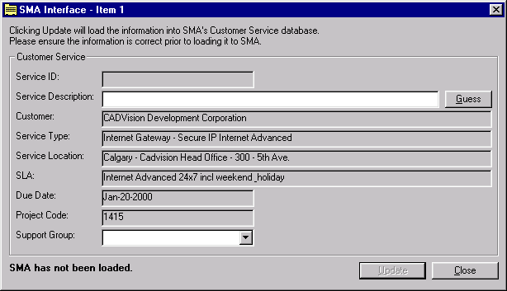
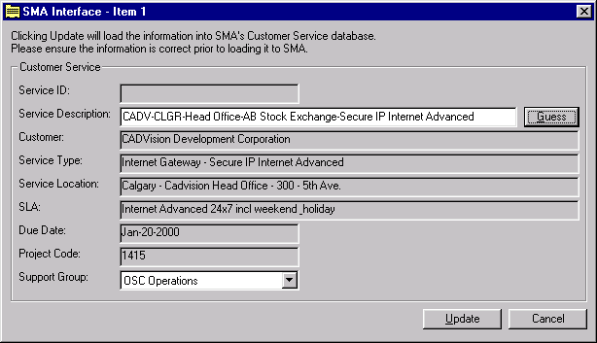
The screen shot above is the SMA screen in DOCS. Select the Guess button to build the service name in DOCS, and correct it, if required. Select the Support Group then the Update button to load the service into SMA. The project code is the DOCS order number.

To create a Customer Service Name, select New on Search screen or Customer Service Detail screen. This is only necessary if no DOCS order is issued.

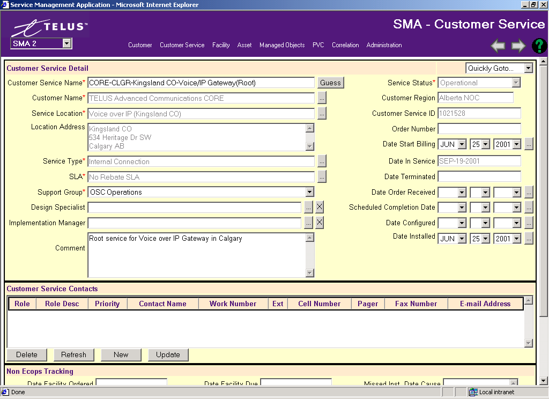

The above screen is an SMA service created in DOCS. The comments field has an automatically generated message to indicate the service was created in DOCS.
Fields:

Customer Service Name – Guess button will assist you to follow format.

Customer Name – Must use Look-Up button on Customer Search screen.

Service Location – Must use Look-Up button on Service Location screen.

Location Address – Information extracted from Service Location screen once Service Location selected.

Service Type – Must use Look-Up button from Service Type (Admin) screen.

SLA – Must use Look-Up button on Service Level Agreement (Admin) screen.

Support Group – Drop-down menu to select which Enhanced group looks after the service.

Design Specialist – Must use Look-Up button on Contact screen. There is also a ‘X’ button to blank out field.

Implementation Manager – Must use Look-Up button on Contact Search screen. There is also a ‘X’ button to clear field.

Comments – If the service was created in DOCS, a comment is added automatically. Otherwise, it is manual input. SAP numbers can be placed here.

Service Status - Codes for a customer service:
DESIGN – When adding a new customer service, the status defaults to ‘design’. A design status indicates that the customer service is not being monitored or supported by the Operations Service Centre (OSC) nor is the customer being invoiced for the service.
OPERATIONAL – The Operations Service Centre (OSC) is responsible for changing the status of a customer service to ‘operational’. An operational status indicates the customer is free to use the service, OSC is fully monitoring and supporting the customer service, and Customer Care is invoicing the customer for the service.
TERMINATED – The Operations Service Centre (OSC) is responsible for changing the status of a customer service to ‘terminated’. A terminated status indicates the customer can no longer access and use the service, OSC is no longer monitoring and supporting the customer service, and Customer Care is no longer billing the customer for the service.

Customer Region – Extracted from Customer Search screen, The Customer NOC Region as defined in Customer Management.

Customer Service ID – A unique system generated number.

Order Number - DOCS order number.

Date Start Billing – Same as the Date In-Service.

Date In-Service – Automatically populated when the service is made Operational by OSC.

Date Terminated – Automatically populated when the service is changed from ‘Operational’ to ‘Terminated’ by OSC.

Date Order Received – Manually populated, based on DOCS.

Scheduled Completion Date - Date the customer service is expected to be operational.

Date Configured – If equipment needs to be configured, this date is added.

Date Installed – Manually populated when the installer phones in to confirm the installation is complete.

The following information is used for Facility Order Tracking and Monitoring. Facility tracking is done in ECOPS, so it is not necessary to enter the following dates.

Date Facility Ordered – The date facility was ordered.

Date Facility Confirmed – Date the facility provider confirmed the facility order.

Date Facility Due – Date the facility should be operational.

Date Facility Ready – Date the facility was ready.

Missed Inst. Date Cause – A free form field used to enter information about why the install date was missed.

Create, Change, or Delete Customer Service Contact Detail

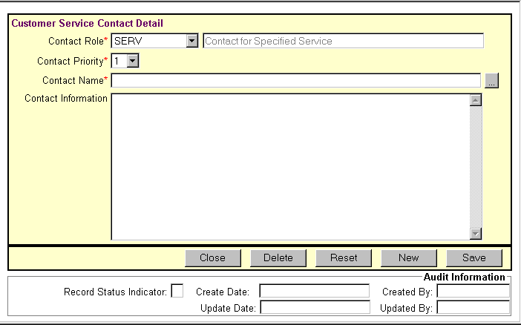

Fields:

Contact Role – Automatically populated with Contact for Specified Service.

Contact Priority – Select from 1 – 10 in Priority via drop-down menu.

Contact Name – Must use Look-Up on Contact Search screen.

Contact Information – Will be extracted from Contact Search screen when contact selection made.

From this screen you can Quick GoTo – Customer, Service Location, Facility, Managed Object, PVC, Order History, Correlation, or Correlation (Root) screens.

Change Customer Service Type (Upgrade/Downgrade Service)

To terminate the old service and add a new customer service, see the ‘Create Customer Service’ process. Do not change the service type on an operational customer service. This causes problems for Billing. The service type of a customer service must be changed--ensure the Customer Care – Billing Specialists are informed.

Move Location of Customer Service

- Select the correct address, or create a new one if it does not exist.
- Select or build a service location name.
- When a service is physically moved, change the service location name on the ‘Detailed Circuit Info’ screen.
- Add comment.

Customer Contact – E-mail Setup

From the SMA Main Menu select Customer Service then E-mail Setup.

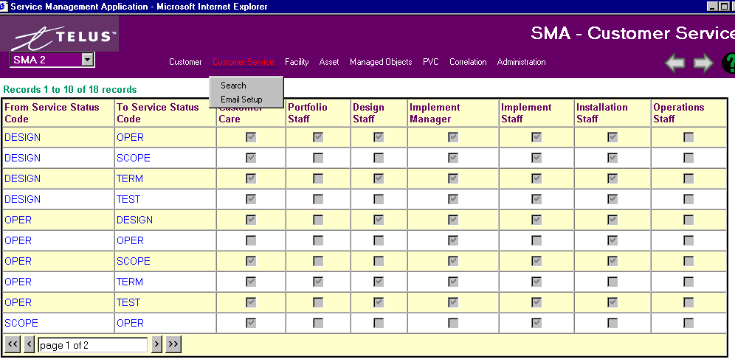

The table above shows which groups receive automatic e-mail distribution when a service status changes form one status to another (service status transition eg. Design to Testing). When an e-mail message is sent, the e-mail address of the managers and specialists are retrieved from the staff table. If the e-mail address is invalid the Microsoft Exchange resolve dialog will appear. If the user elects to cancel the resolution dialog no e-mail message is sent.

Facility Tab

This tab enables the user to search for an existing facility or create a new facility. A facility is a circuit that is ordered from outside of TAC. The facility types are: DCS, Fibre, Frame Relay, ISDN, ADSL, T1 or XDSN. The user can search for the facility name using any of the fields shown below.

A facility name, number or alias can be used in the Facility field when searching. A legal name, short name, or alias name can be used in the Customer Name field when searching.

Also shown on this screen are Service Location A & B, Region and Service Status.

Facility Search

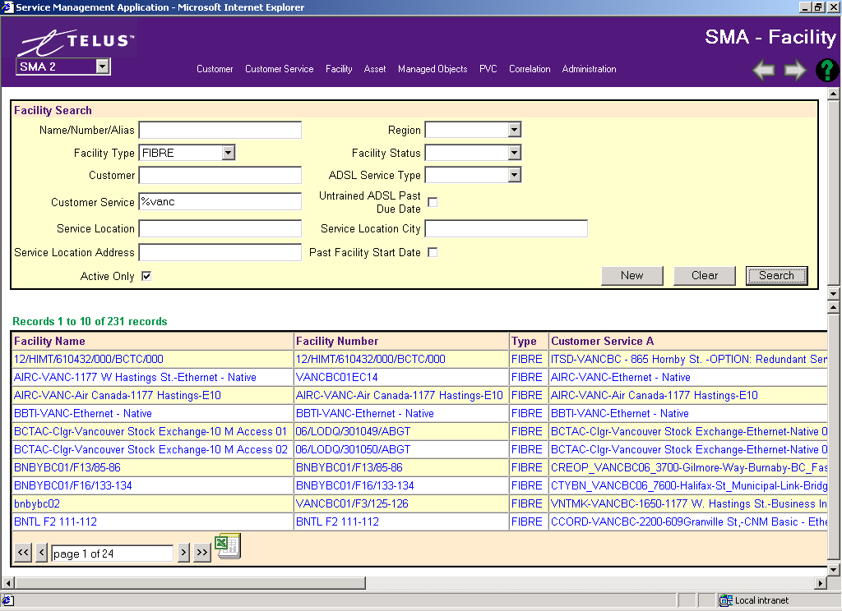

Facility Detail General Information

The Facility Detail screen has different criteria for each facility type, i.e. ADSL, FIBRE, FR, etc.
A circuit is a ‘physical’ path on the network where electronic data travels from one point to another. A network connection is a ‘logical’ connection between two service locations, it is ‘physically’ built as one or more circuits. It is crucial to accurately measure/monitor traffic on every circuit because this is the source of all customer usage calculations required for billing. The following circuits types have been identified: ATM, Fibre, Frame Relay, xDSL and ISDN.

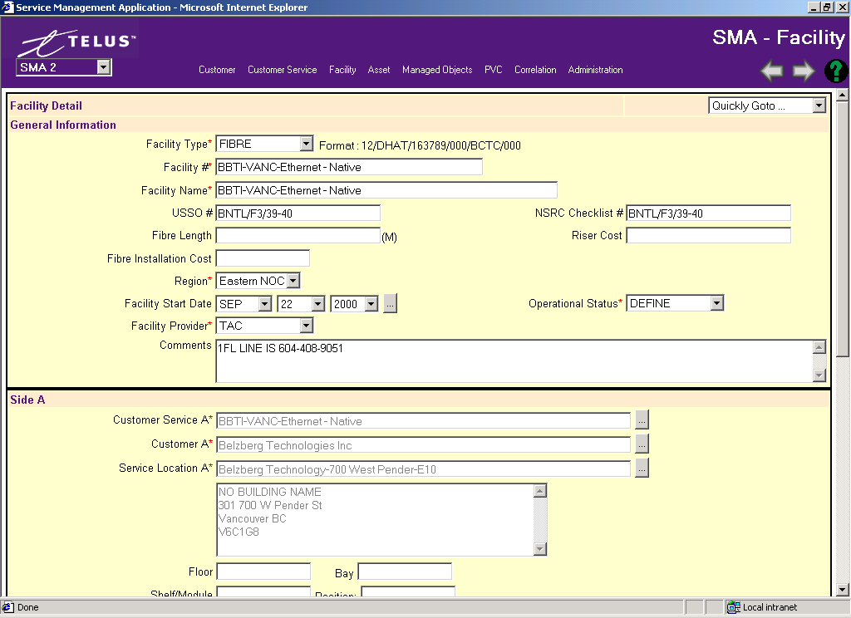
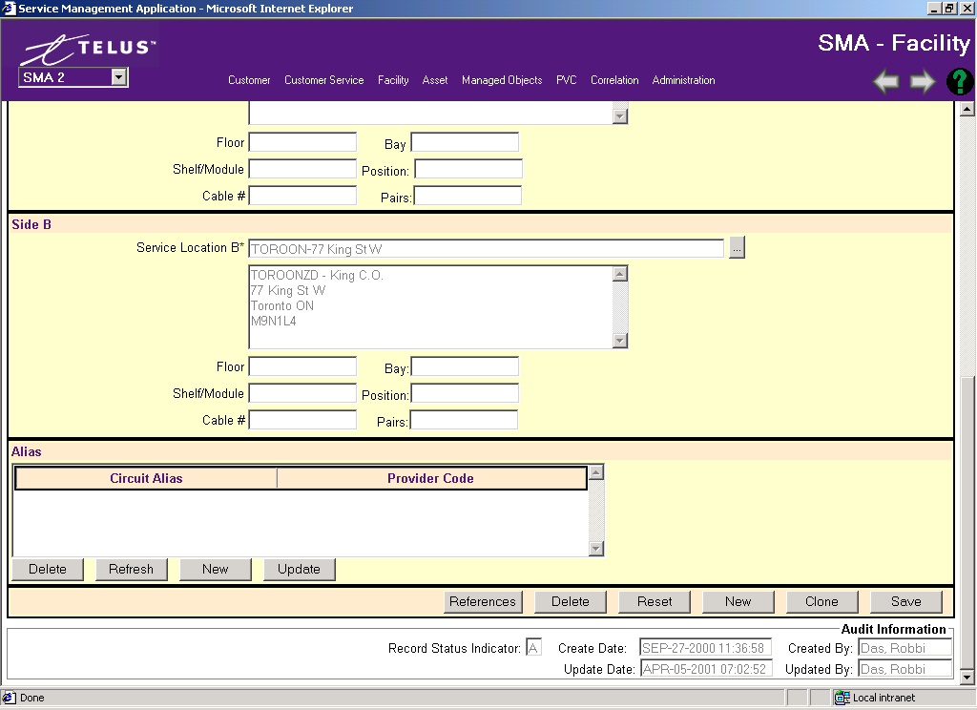

FIELDS:

Facility Type – Select type of facility that is being ordered from drop-down menu.

Facility # - Once a type of facility is selected an example of a circuit number is shown beside the field. Examples are:
Fibre - 06/LODQ/274338/000/ABGT
Frame Relay (FR) - 55/QHDQ/102250/003/BCTC
ISDN - 403-207-8826 / 06/IDDA/305022/001/ABGT
xDSL - 06/ARDR/315992//ABGT
DCS - 12/DYDT/181481/000/BCTC/000
T1 - 06/DHAT/321123/000/BCTC

Facility Name – The Facility name defaults to the Facility #. It can be overwritten.

USSO # - Universal Special Service Order number used to order mainstream facilities.

NSRC Checklist # - National Service Response Centre checklist number used in conjunction with the USSO to order mainstream facility.

Fibre Length – length in meters.

Fibre Installation and Riser Cost – Fields used to track costs of these two items.

Region – select from drop-down menu the NOC region responsible for the circuit.

Facility Start Date – The facility start date specifies the date the circuit was operational and available for use by the customer. Either use drop-down menu or Look-Up button.

Facility Provider – select from drop-down menu the area the circuit belongs to.

Comments – Any additional comments concerning this facility.

Operational Status – The Status helps to define the stage the circuit is in.
OPER - Operational. Indicates the facility is used by a customer service, but not being billed.
PNDOUT - Pending Out. Indicates the circuit is coming out.
DEFINE - Used to indicate the circuit is being built in SMA.
SPARE - Not used, should be deleted from list.
TERM - Terminated. Indicates the facility is no longer in use by a customer service.

Side A - When a new circuit is entered in to the system, Customer Service A is always required. This identifies the customer and for what service the circuit belongs.

Customer Service A – Must use Look-Up button to the ‘Customer Service Search’ screen.

Customer A – Must use Look-Up menu to the ‘Customer Name Search’ screen.

Service Location A – Must use Look-Up menu to Service Location Search screen. The Service Location A defines the ‘from’ location. The circuit begins at the A (from) location and connects to the B (to) location. The Service Location defines every aspect of a locations whereabouts for a specific customer. It begins by stating the city that the service location can be found in. The city name should be full-length beginning with a capital letter. Following is the name of the organization. The client short name is used to enter the name of the organization. This should be the same short name used on the main Customer Management screen. Finally, is the street address. A minus sign ( - ) with a space on either side should be placed between each section as a divider.

Example: Calgary - TAC - CO - Suite 200 355 - 4th Ave SW

USSO # - Universal Special Service Order number used to order mainstream facilities.

NSRC Checklist # - National Service Response Centre checklist number used in conjunction with the USSO to order mainstream facility.

Fibre Length – length in meters.

Fibre Installation and Riser Cost – Fields used to track costs of these two items.

On Side A & B: Indicates what floor, bay, shelf/module, position, cable number, and pairs used.

Side B - Customer Service B is only required when a PVC circuit or network connection is entered into the system.

Service Location B – Must use Look-Up menu to ‘Service Location Search’ screen. The Service Location B defines the ‘to’ location. The circuit begins at the A (from) location and connects to the B (to) location. The Service Location defines every aspect of a location’s whereabouts for a specific customer. It begins by stating the city that the service location can be found in. The city name should be full length beginning with a capital letter. Following is the name of the organization. The client short name is used to enter the name of the organization. This should be the same short name as seen on the main ‘Customer Management’ screen. Finally is the street address. A minus sign ( - ) with a space on either side should be placed between each section as a divider.

Example: Edmonton - EPSB - One Kingsway Ave

ALIAS

Clone Circuit - Creates a new circuit identical to the circuit displayed, minus the circuit name and circuit number. These fields need to be populated with the new circuit name and number in order to save the circuit.

Comments - This field can be used for any comments or extra information. This field is free form up to 2000 characters.

Circuit Alias Numbers - Only complete this information when a circuit used in the Customer Service is provided by a company other than TAC. This field holds information about the circuit that can be used to refer to it in the other company.

Provider Code – The name of the company providing the circuit.

Facility Details Specific to Service

ADSL:

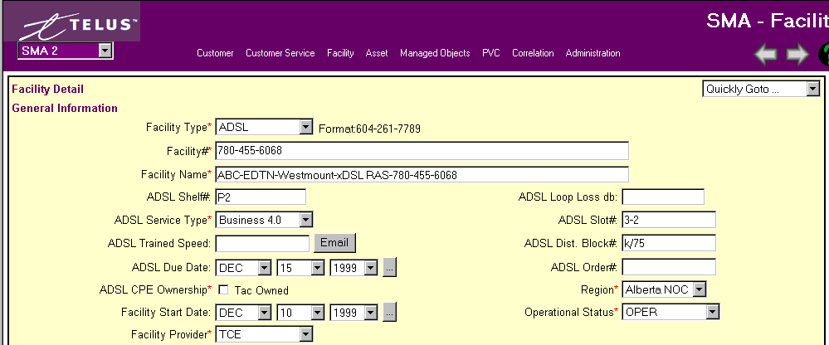

Fields:

ADSL Shelf , ADSL Service Type, ADSL Trained Speed, ADSL Loop Loss db, ADSL Dist. Block # - Details of ADSL facility. See Infosource for additional information.

ADSL Due Date – Date facility is ready for customer to use.

ADSL Order # - Order number installing service.

ADSL CPE Ownership – When selected, Customer Premise Equipment owned by TAC.

FIBRE:

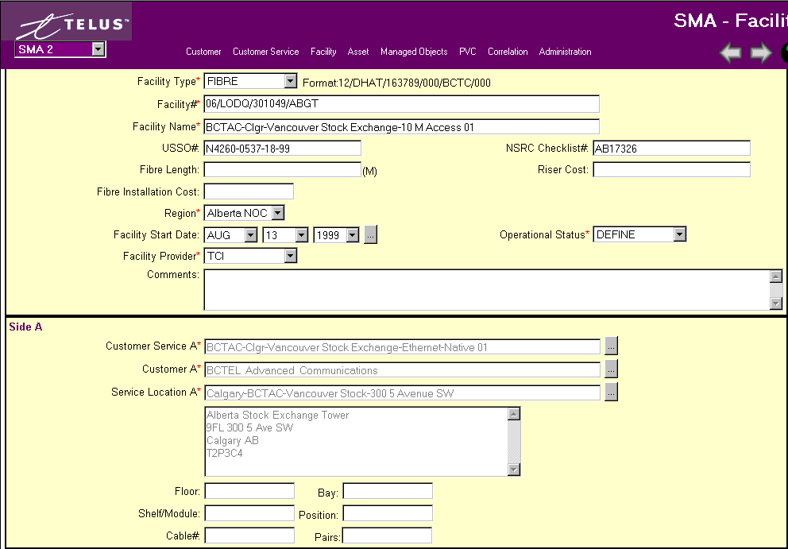

USSO # - Universal Special Service Order number used to order mainstream facilities.

NSRC Checklist # - National Service Response Centre checklist number used in conjunction with the USSO to order mainstream facility.

Fibre Length – length in meters.

Fibre Installation and Riser Cost – Fields used to track costs of these two items.

On Side A & B: Indicates what floor, bay, shelf/module, position, cable number, and pairs used.

FR (Frame Relay):

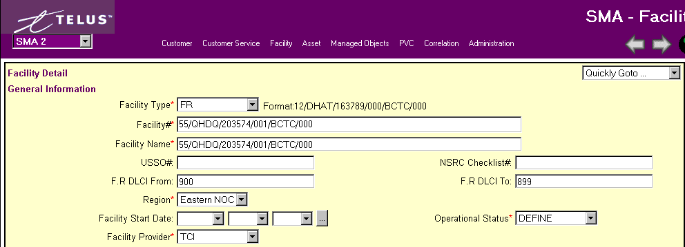

USSO # - Universal Special Service Order number used to order mainstream facilities.

NSRC Checklist # - National Service Response Centre checklist number used in conjunction with the USSO to order mainstream facility.

FR DLCI From/FR DLCI To – The Frame Data Link Connection Identifiers are assigned to a facility.

ISDN/T1/XDSN:

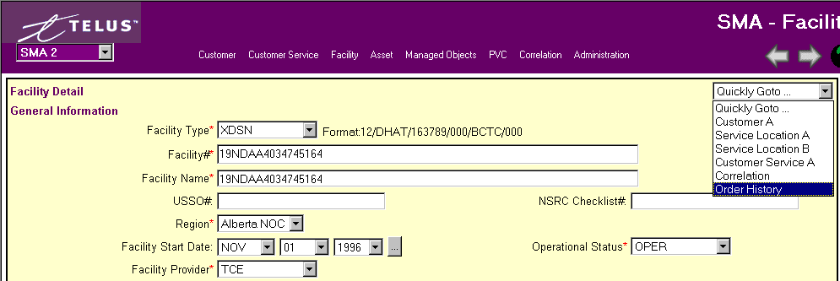

USSO # - Universal Special Service Order number used to order mainstream facilities.

NSRC Checklist # - National Service Response Centre checklist number used in conjunction with the USSO to order mainstream facility.

From Facility Quickly GoTo, either Customer A, Service Location A or B, Customer Service A, Correlation or Order History screens.

Asset Tab

This tab enables the user to search for existing or create new asset information. By selecting the Asset field, an additional navigational menu appears. The options on the additional navigational menu are:
- Search
- Asset Catalogue
  - Asset Catalogue
  - Make
  - Model
  - Part Number
- Asset Classification
  - Asset Class
  - Asset Subclass
  - Asset Type

Asset Search

From the SMA Main Menu select Asset then Search. The user can search for an asset by using any of the fields shown below. A legal name, short name, or alias name can be used in the Customer Name field when searching. Shown on this screen are address and region.

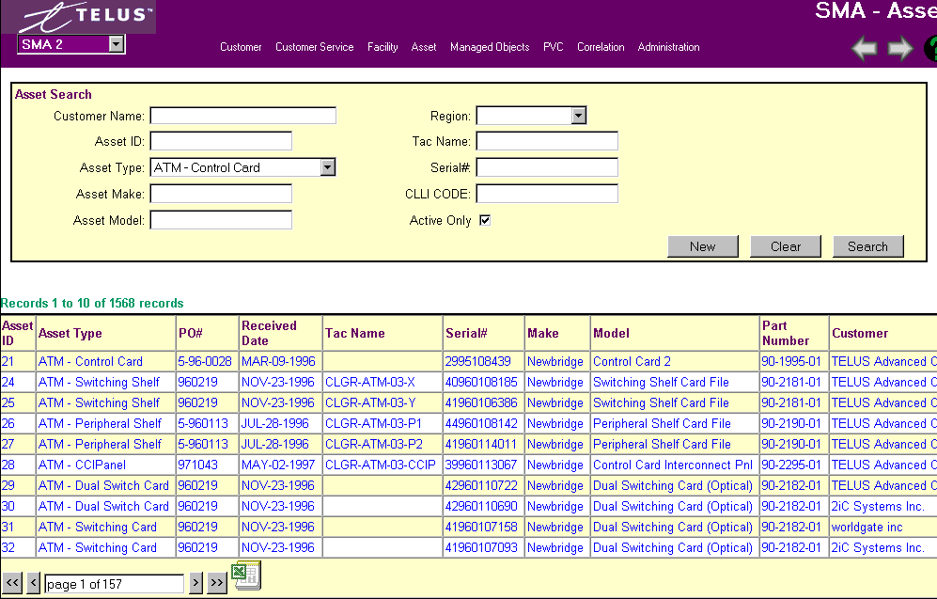

Asset Detail Identification

This screen is accessed when a specific asset is selected. It provides all the details regarding the specific asset.

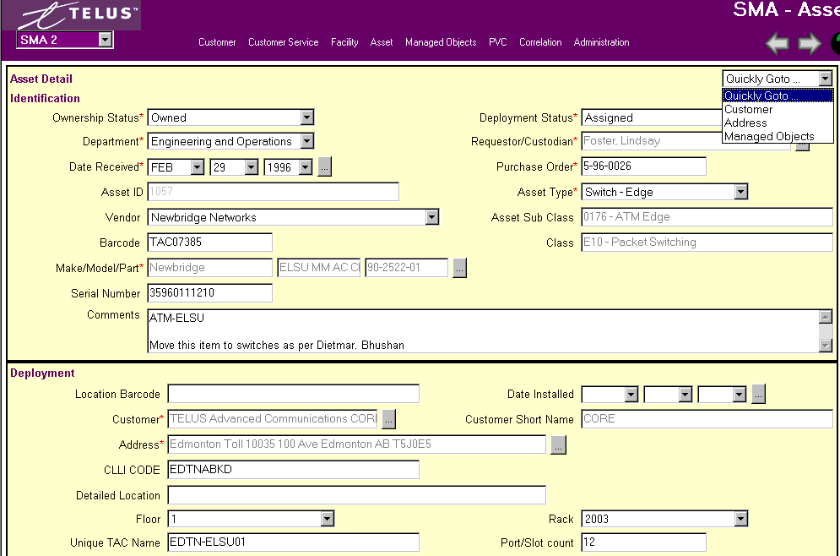
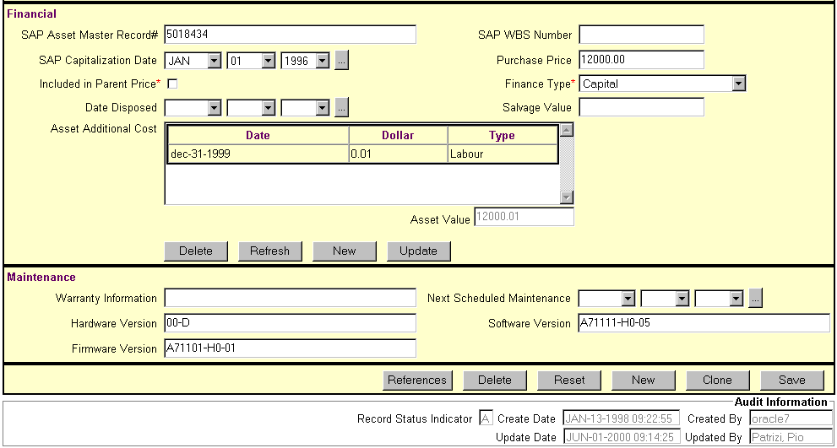

Fields:

Ownership Status - The majority of assets are owned. The other situation is they belong to a customer and TAC is simply managing them (‘Not TAC’).

Deployment Status - Initially set to ‘pending’ by the receiver, the installer will reset this status once the asset has been put into service. All assets that are part of the managed network should be set to ‘Manageable by OSC’. Other assets are ‘assigned’ unless they are a ‘maintenance spare’. Any of the other statuses indicate the asset is no longer an active asset within the company.

Department – Select from drop down menu, i.e. Engineering and Operations - All items (‘real’ and ‘virtual’) are part of the configuration of a service for a customer – their make and model and their physical location. Provides an inventory of items in service with their locations, for network and configuration planning. All items (‘real’ and ‘virtual’) can be alarmed for automated trouble ticketing – their location and customer the asset is used for. These assets do not need to be owned by TAC as we manage equipment on behalf of customers. By linking network alarm sources to assets, information regarding affected services and customers can be extracted and the appropriate people contacted regarding current or potential problems. Managed Services - All items that we own, manage or purchase on behalf of outsourcing clients. Provides detailed information regarding activities undertaken on behalf of outsourcing clients.

Requestor/Custodian – Must use Contact Search look up for selection.

Purchase Order - Purchase order field required.

Asset Type - When selecting this item, check the asset sub-class information displayed to ensure the asset type maps to the sub-class you would expect. Asset ID, asset sub-class, and class fields are automatically populated when the asset type selection is made.

Make/Model/Part – Must use to look up to Search Asset Catalogue.

Serial # - Enter serial number from equipment.

Comments – Any additional information concerning this asset.

Vendor – Select from drop-down menu the company the equipment is purchased from.

Bar Code - Record the bar code placed on the asset.

Asset Serial Number - Serial number is a required field and should only be set to ‘unknown’ in situations where it is genuinely difficult to determine the serial number (e.g. part is already installed deep within some other asset).

Unique TAC Names - are formatted using standards developed by Engineering and Operations. This name must match the one used in the network monitoring software to tie alerts together.

SAP Asset Management Record # and associated SAP Capitalization Date are the indication to the system this asset is reconcilable to the SAP Asset Management module and therefore should be included in all reconciliation reporting.

A number of the fields on this screen are mandatory for assets grouped in SAP. Many of the fields are currently disabled for assets held individually in SAP (no need to hold the data in two places). For SAP pooled assets, entry is optional.

The additional asset dollar entry fields are used to capture information about costs attributable to the asset but are over and above the direct purchase price.

Maintenance section - provides free format fields to hold maintenance scheduling and version number information.

Cloning - From the asset add/edit screen, the currently displayed asset is used as a template to create a clone asset. The new asset uses the field values from the old asset to facilitate data entry. There is no permanent relationship between the two records. When entering a new asset, finding a similar one and cloning it, is significantly faster than entering all the data from scratch.

Asset Catalogue Search - Make, Model and Part Search

Searches for a make, model, part number or asset class, subclass, or type can be done through the Asset Catalogue search or individually through Make, Model or Part Number Search.
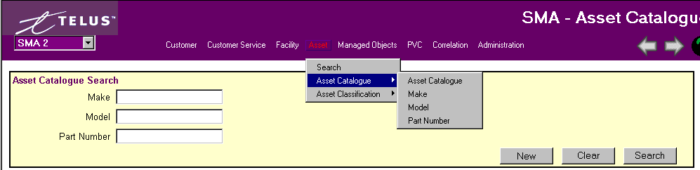

Asset Classification Search – Asset Class, Asset Subclass, Asset Type

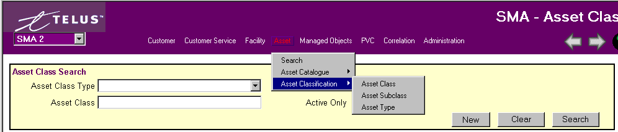

Create, Change, or Delete Asset Catalogue, Make, Model, Part Number and Asset Class, Subclass or Type

Add/Delete Make, Model or Part Number from Asset Catalogue Details. Each item will require you use the Look-Up buttons for each search screen. Asset Class, Subclass and Type information is usually input by the Finance area.

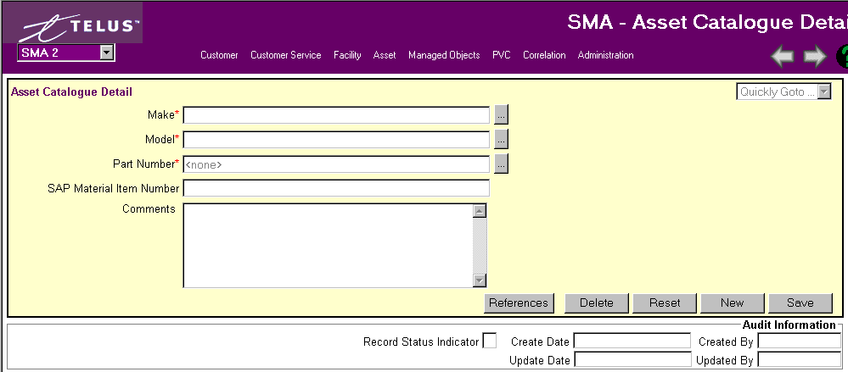

Managed Objects Tab

This tab enables the user to search for existing or create new managed objects information. Managed Objects are anything managed or monitored by TAC. They are defined for network and service management purposes and are the fundamental components that make up a customer service. The managed objects provide the necessary correlation between services and network resources.

Search Managed Objects

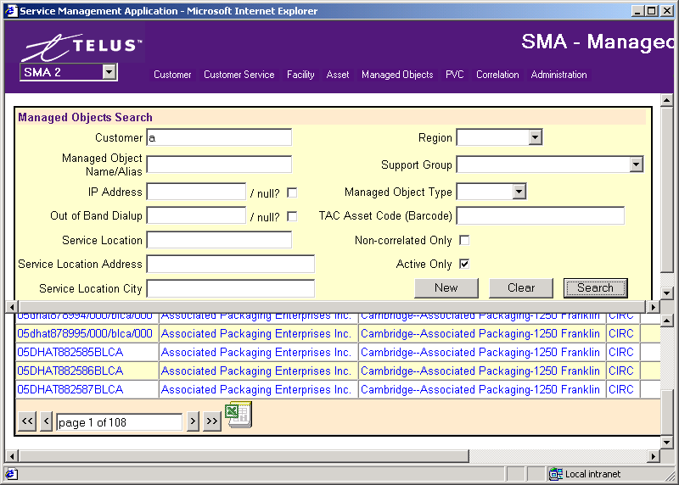

Search for a managed object by using any of the fields shown above. A legal name, short name, or alias name can be used in the ‘Customer Name’ field when searching.

Create Managed Object

Fields:

Object Name – The Managed Object Name is usually described as a device name or a URL. A list of all managed object names begin with the CLLI code of the Central Office the device is located in or works out of, followed by the customer short name, followed by a number to reveal how many devices there are for the customer.

Examples:
EDTNAB02-BLCR01
VANCBC01-CADV01
www.tac.TELUS.com

Object Description – A freeform used to describe or differentiate the Managed Object when needed. This field should be used to specify the device type i.e. Cybersurf AS5300.

Object Type – Select from the dropdown menu. The Managed Object Type controls the fielding in order to collect additional information i.e. for routers & edge devices.

Alias Name – If the Managed Object is referenced by another name outside of TAC, enter it here.

IP Address – The address OSC uses when sending SNMP requests and pings.

MAC Address – The hardware address of the interface the Managed IP Address is assigned. It enables the Operations Service Centre to identify TAC’s router for management purposes. This prevents unauthorized access from the customers network into TAC’s Operations Service Centre. Only OSC bound traffic is allowed to pass through the secure connection. The MAC Address consists of 12 characters, both letters and numbers. They are grouped into two’s with divisions by a minus sign ( - ).

Example: 00-00-0C-FE-F8-30

Asset, Make/Model/Part#, Serial#, Bar Code - Look-Up button and information from 'Asset' screen.

Out of Band Dial up - The phone number used by OSC to make contact with the managed object when the primary circuits are unavailable. These are considered a facility and are added to the database and attached to the Customer Service by the Implementation Managers. Only the phone numbers (IBL Facilities) attached to the service location will appear in this list. Select the number applying to the managed object. If the correct number does not appear in the list, contact the Implementation Manager specified on the 'Customer Service Management' screen.

Customer/Customer Short Name - All managed objects must be linked to a customer service. Use Look-Up menu on 'Customer Search' screen.

Service Location/Service Location Address – Look-Up menu from 'Service Location Search' screen. This list contains the addresses of all customer services in the database. If the customer service location does not exist in the list, contact the Customer Service Management Super User (Lee Ettinger).

Support Contact Role - A more refined breakdown of the Support Group.

Support Group - The group responsible for Service Assurance.

Comments – A freeform field the design engineer can use to enter any additional information about the managed object not captured elsewhere.

Inactivate Managed Objects

A managed object can be inactivated by selecting ‘TERM’ from the status field drop down menu. The system automatically sets the termination date to the current date. If equipment is no longer at a customer service location it can be deleted from the managed object. This equipment still shows up in the 'Asset Detail Screen'.

Move from Managed Objects to ‘Quickly GoTo’ to take you directly to Customer, Service Location, Correlation and Asset screens.

PVC Tab

This tab enables the user to search for existing or create new PVC information. A new feature of this SMA release is the ability to narrow search results by selecting a ‘Create From’ and ‘Create To’ criteria of PVCs.

Operations Service Centre (OSC) has accepted the responsibility to ensure the logical customer service connections are maintained so usage can be billed to customers.

When a new ATM PVC is set up in the ATM Network it automatically detects and inserts into the database an Operational Status of ‘UNKNWN’.

IMPORTANT
To bill for usage on ATM PVCs, the following PVC Management information must be completed:
- Usage Calc Type (Billing),
- Side A Information,
- Side B Information.

For each day the above pvc management data is missing, the customer will not be billed for usage collected on that day.

Search PVC

Verify the Outstanding PVC box is selected to obtain these statistics. Search for a PVC by using any of the fields shown below. Shown on this screen are Customer Service B, Service Location A & B, Region, PVC Status, Create Date (From and To), and Active Only and Outstanding/Uncorrelated PVCs checkboxes.

A new feature of this SMA release is the ability to select a date range of created PVCs utilitizing the ‘Create Date (From and To)’ fields. The search results display only PVCs created during the selected date range.

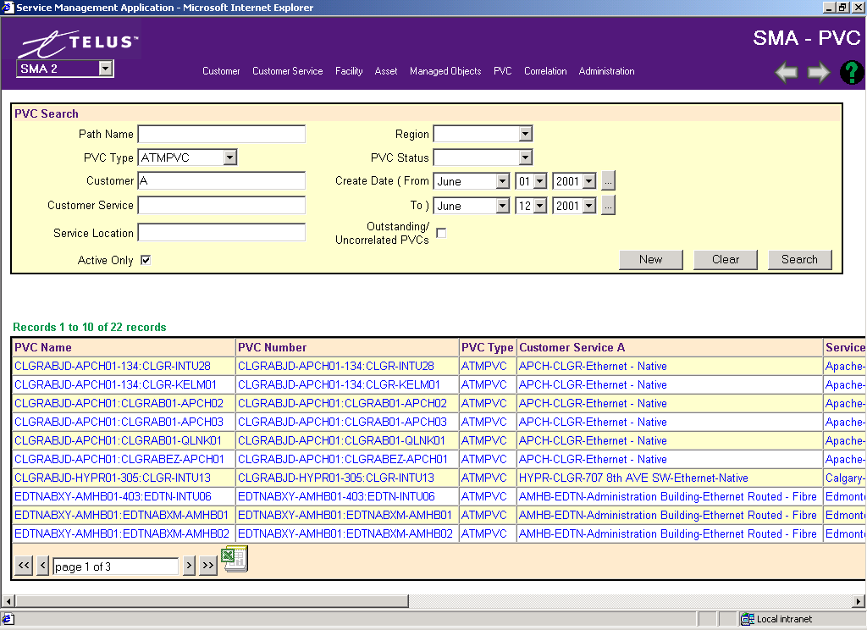

Create, Change, or Delete PVC Detail General Information

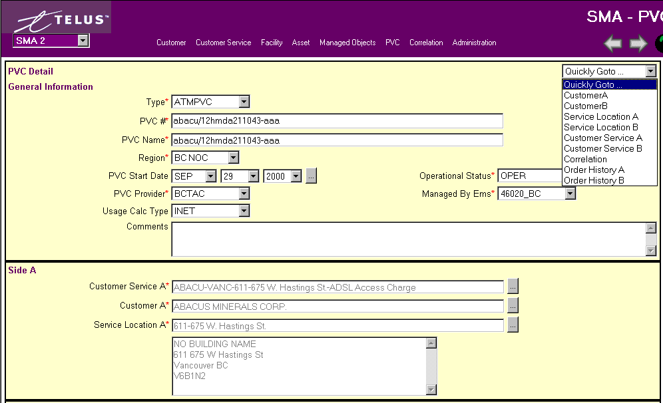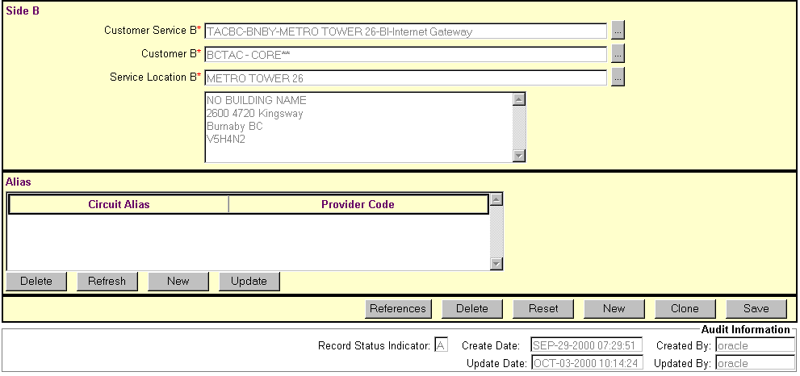

Fields:

Type – Always ATM-PVC.

PVC #/PVC Name - The PVC # is a unique number referencing the PVC circuit. This field is populated with the circuit number from the ATM Network when the circuit is auto discovered. The PVC name will default to be the same as the PVC number. It may be overwritten to insert a more user-friendly description.

PVC Start Date – The date the ATM PVC was auto-discovered. It is the date the system can start collecting usage. The date is inserted by the circuit discovery process, but it can be overwritten.

PVC Provider – The organization that provisions the circuit. For ATM PVCs the circuit provider is always TAC. The system will default the value to TAC, but the value can be overwritten.

Operational Status Code – Drop-down menu used for selection.
- UNKNWN – Unknown. This status is used for ATM PVC circuits only. A status of UNKNWN is set when the ATM PVC is auto discovered by the Usage Collection Process. A circuit having an ‘UNKNWN’ status will not generate revenue because the usage is not passed to the billing system.
- OPER – Operational. This status indicates the PVC has been fully connected. It is collecting usage for a Customer Service.
- TERM – Terminated. This status indicates the PVC is no longer in use by a Customer Service.
- PNDOUT - Pending out of circuit.
- SPARE - PVC not in use at this time.
- DEFINE - being built in SMA

Managed By EMS – The name of the Element Management Software monitoring the circuit.

The Billing Type drop box existed in SMA1 has no affect on billing. Local vs. IX charges were determined (and still are) based on the A-end and B-end service location cities assigned to the PVC.

Usage Calc Type: There are 3 options available:
- FREE – The PVC is not billed to the customer. If you have a PVC to be used for statisticss collection only, set the indicator to ‘Free’.
- INET – The PVC connects an internetworking service where both sides of the service are billed for receipt usage.
- LANIC – The service is a LAN Interconnect and only one side of the service is being billed to a customer and the other side connects to a TAC CO or POP.

Side A and Side B information is the logical connection of the PVC circuit. Side A and Side B are mandatory fields. They are required for the billing system and customer reporting to function properly.

Side A
Customer Service A - must be selected from the Look-Up button that goes to ‘Customer Search’ screen.

Customer A - defaults to the customer name specified on the ‘Customer Service Management’ screen.

Service Location A – default to the service location specified on the ‘Customer Service Management’ screen.

Side B
Customer Service B - selected from the Look-Up button that goes to ‘Customer Search’ screen.

Customer A - defaults to the customer name specified on the ‘Customer Service Management’ screen.

Service Location B - defaults to the service location specified on the ‘Customer Service Management’ screen.

Comments – Freeform field for information not captured elsewhere can be entered.

Circuit Alias - Any other Facility/PVC alias which helps to search for this PVC can be entered here.

Provider Code – The name of the company providing the circuit. Used with Circuit Alias information.

Correlation Tab

This tab enables the user to search for existing or create new correlation information. It makes a customer service operational.

Search Correlated Elements

Search for a Correlation information by using any of the fields shown below. A legal name, short name, or alias name can be used in the Customer Name field when searching. If the Customer Service Name does not appear in the list, contact the Implementation Manager. Also shown on this screen are Service Type, Customer Name, and Region.

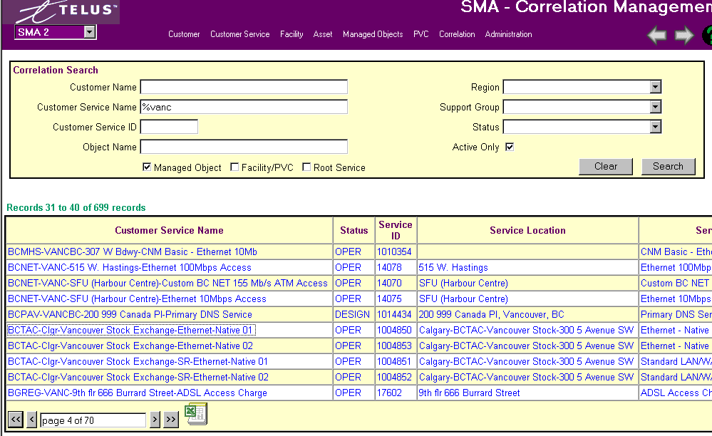

Managed Correlation Detail Information

To attach a network element to a customer service you want to select a managed object, PVC, facility or root service to the correlated elements on the ‘Managed Correlation Detail’ screen.

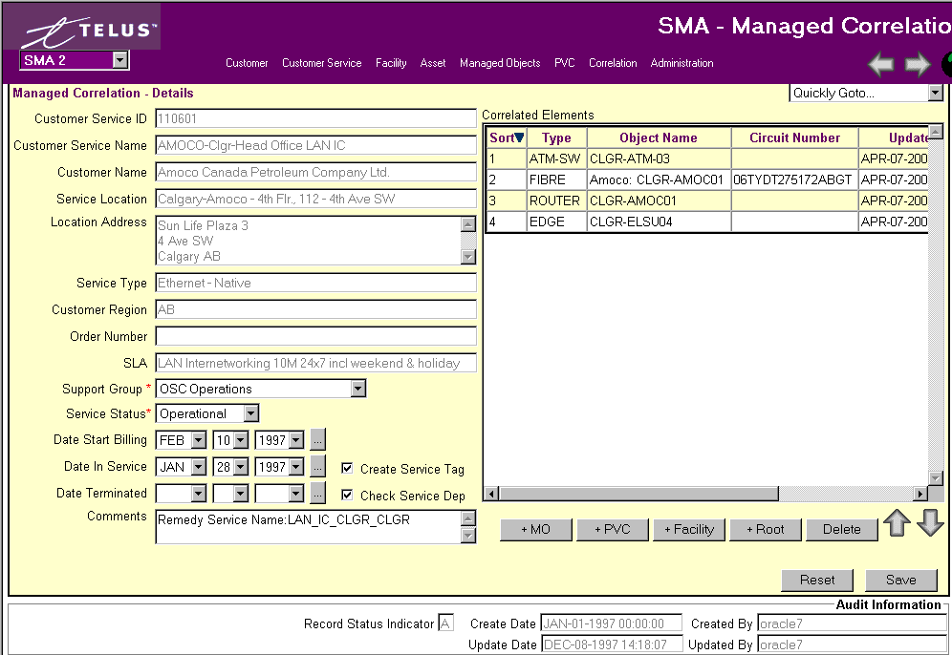

The correlated elements are sub-divided into 4 sub-component types: managed objects, PVCs, facilities, and root services. A root service is a service that correlates commonly used network elements used by a variety of other services, i.e. infastructure. When choosing one of these elements the search screen appears.

The list of correlated elements can be sorted by any of the fields by choosing the field title. Each element can be moved on the list using the down and up arrows found beside the Delete button.

To remove a correlation element from a customer service, select the component from the list. Then select the Delete button.

To view a correlation element, select the element name from the list and use the Quickly GoTo menu.

Activate/Terminate Customer Service

There are three valid status codes for a customer service.
- DESIGN – Implementation Managers are responsible for adding new customer services. New customer services have a status of ‘design’. A design status indicates the customer service is not monitored or supported by the Operations Service Centre (OSC) nor is the customer invoiced for the service.
- OPERATIONAL – The Operations Service Centre (OSC) is responsible for changing the status of a customer service to ‘operational’. An operational status indicates the customer is free to use the service, OSC is fully monitoring and supporting the customer service, and Customer Care is invoicing the customer for the service.
- TERMINATED – The Operations Service Centre (OSC) is responsible for changing the status of a customer service to ‘terminated’. A terminated status indicates the customer can no longer access and use the service, OSC is no longer monitoring and supporting the customer service and Customer Care is no longer billing the customer for that service.

To activate a customer service, set the customer service status to ‘operational’. The system automatically sets the Date In-Service to the current date. This date can be overwritten.

To deactivate a customer service, remove all network elements correlated to the service. Set the customer service status to ‘terminated’. The system automatically sets the ‘Date Terminated’ to the current date. This date can be overwritten.

IMPORTANT:
When a customer service is activated or deactivated, the Customer Service Manager and the Billing Specialist must be informed. The system generates an e-mail note. Verify the recipients of the note and confirm there is a Customer Service Manager and a Billing Specialist, if not add them to the recipient list. Select the Send button on the e-mail—do not cancel the e-mail message!

Use Quickly GoTo to go directly to the Customer Service, Customer, Order History, Root Customer Service, Facility, Managed Object or PVC screens.

Order History

Search Order History

From the Quickly GoTo screens of Customer Service, Facility, PVC (either A or B) or Managed Correlation you can see Order History. This screen also shows site address.

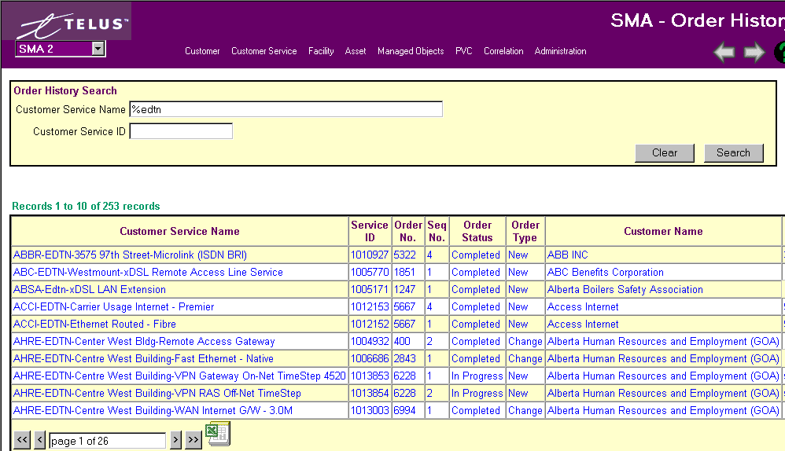

Display Order History Detail

This screen is read-only with historical information of the order. Select the Search button at the bottom to take the user back to the Search screen shown above.

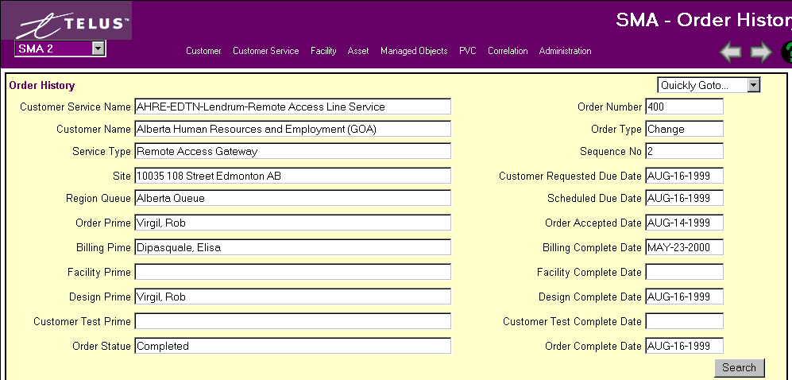

Administration Tab

Admin searches are mainly informational screens, maintained by various groups, i.e. Marketing, Super-Users. The Security Matrix shows what access each group has to SMA.

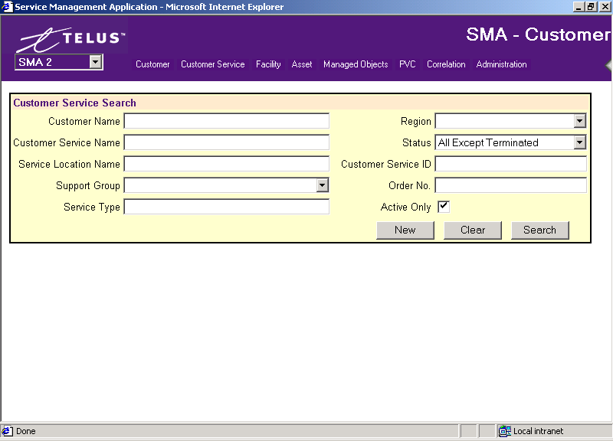

The CLLI code is a four character city code, followed by a two character province code, followed by a two character office code. i.e. CLGRAB02

